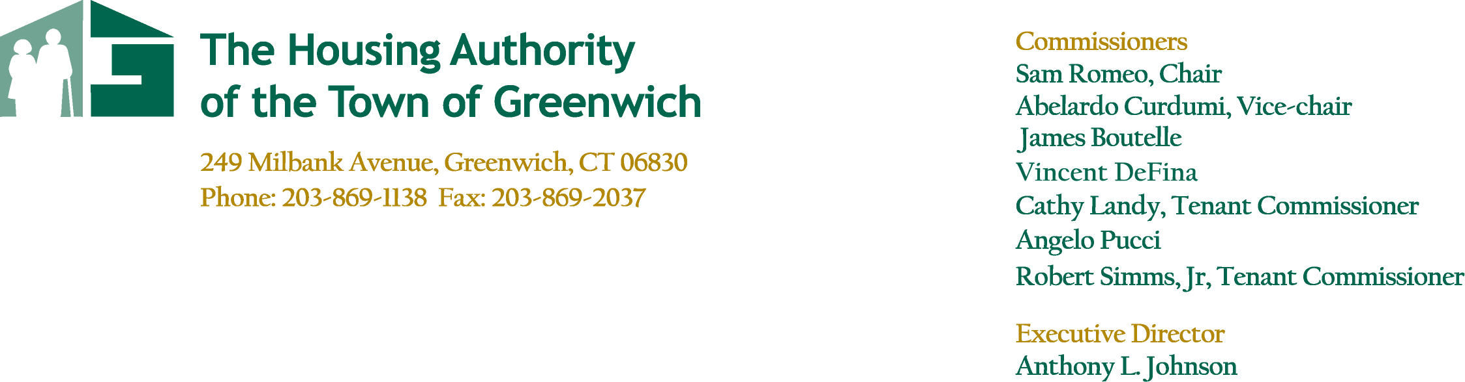

Agenda
June 23, 2021

Regular Board of Commissioners Meeting
Conference Call – 5:30pm

Call to Order- Resident Comment Period

Approval of Minutes
Regular Board Meeting – May 26, 2021

Committee Reports
- Finance Committee Meeting – June 23, 2021
- Overall Results
- Acquisition of One New Property - Approval
- Development Committee Meeting – No Meeting
- Armstrong Court
- Administrative Committee Report – No Meeting
- Other Residences Committee Report – No Meeting
- Parsonage Cottage – P. Lore
- Greenwich Close – J. Longo

Executive Director’s Report
- Coronavirus Update
- Operations – Armstrong Court – Phase I, Phase II & Phase III, CDBG
- Greenwich Close Refinance

Report Summary – T. Mardula

Housing/Deputy Director’s Report
- Monthly Property Report
- Public Housing Manager Reports
- Maintenance Report

Other/New Business

Executive Session
- Letter of Support – Other Developer

- Adjourn

EQUAL OPPORTUNITY AGENCY

