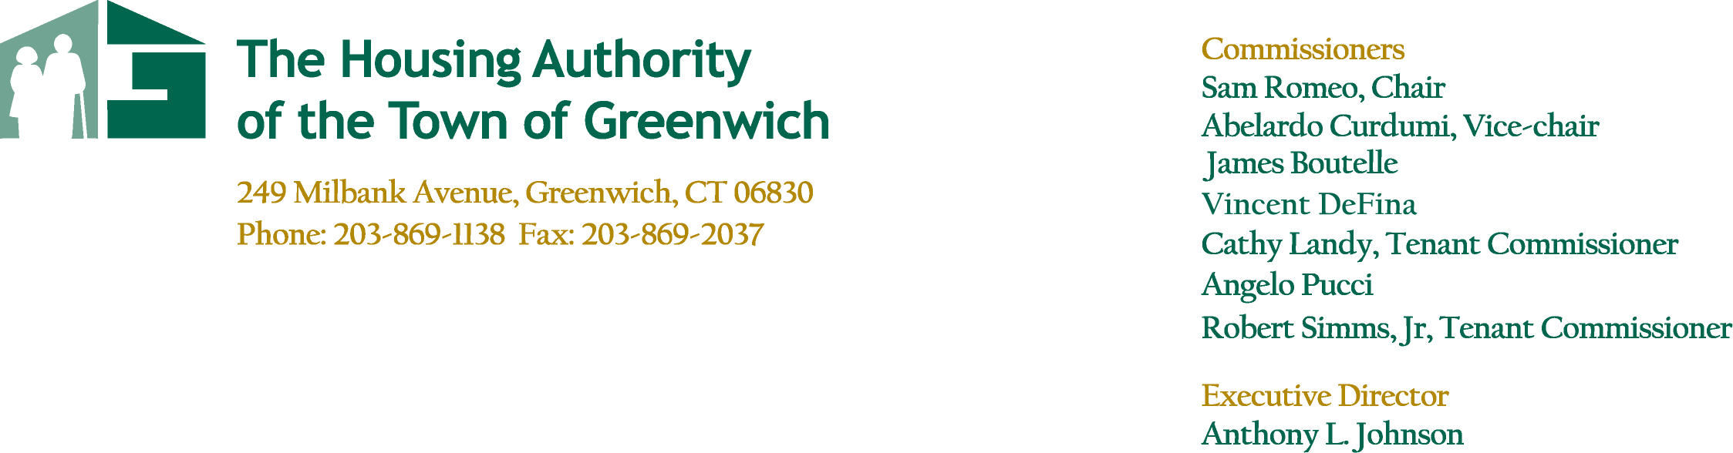
Agenda
April 27, 2022

Regular Board of Commissioners Meeting
Conference Call – 5:30pm

Call to Order- Resident Comment Period

Approval of Minutes
Regular Board Meeting – March 23, 2022

Committee Reports
- Finance Committee Meeting – April 27, 2022
- Overall Results
- Development Committee Meeting – No Meeting
- Armstrong Court
- Administrative Committee Report – April 12, 2022
- Other Residences Committee Report – No Meeting
- Parsonage Cottage – P. Lore
- Greenwich Close – J. Longo

Executive Director’s Report
- Operations – Armstrong Court – Phase I, Phase II & Phase III
- Greenwich Close Refinance
- Quarry Knoll II Update
- Vinci Gardens Update
- CDBG Recommendation for Agnes Morley Heights

Report Summary – T. Mardula

Housing/Deputy Director’s Report
- Monthly Property Report
- Public Housing Manager Reports
- Maintenance Report

Other/New Business
- New Policy Requiring Resident Insurance

Executive Session
- Employee Merit Increase

- Adjourn

EQUAL OPPORTUNITY AGENCY

