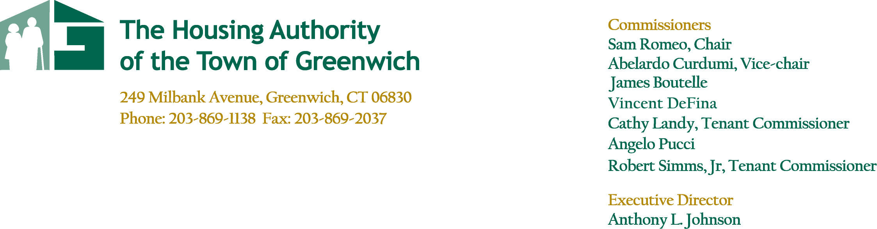

**Agenda**

**May 24, 2023**

**May Board of Commissioners Meeting**

***Conference Call – 5:30pm***

##### Call to Order- Resident Comment Period

##### Approval of Minutes

**Regular Board Meeting – April 26, 2023**

##### Committee Reports

1. **Finance Committee Meeting – May 24, 2023**

* **Overall Results**

1. **Development Committee Meeting – No Meeting**

* **Armstrong Court**

1. **Administrative Committee Report – No Meeting**
2. **Other Residences Committee Report – No Meeting**

* **Parsonage Cottage – P. Lore**
* **Greenwich Close – J. Longo**

##### Executive Director’s Report

* **Operations – Armstrong Court – Phase 2 & Phase 3**
* **Vinci Gardens Update**

##### Report Summary – T. Mardula

**Housing/Deputy Director’s Report**

* **Monthly Property Report**
* **Public Housing Manager Reports**
* **Maintenance Report**

1. **Other/New Business**

* **Resolution #525 – HTCC Application for Armstrong Court Phase 3**

##### Executive Session

1. **Adjourn**



EQUAL OPPORTUNITY AGENCY